Trial 3 Final RGB and Multispectral Synthesis Report
This report combines the RGB and multispectral outputs from the Third Trial workflow. The RGB results describe visible emergence and green-cover development, while the multispectral results describe relative image-derived NDVI and NDRE responses. The aim is to provide one final tray-level and treatment-level interpretation for Trial 3.
Observed Day 7 values are preserved as the primary record. Adjusted Day 7 values remain separate and represent a flagged analytical scenario for cells where earlier seedlings may have disappeared due to bug damage.

1. Input files checked
The synthesis used the main tray-level outputs from Script 05 and Script 08. Group and Inside/Outside tables were also checked as reference outputs, but the final group summaries were recomputed from tray-level values so that RGB and MS were combined consistently.
Source | Exists | Used | Notes
RGB tray growth metrics | True | Yes | Main RGB tray-level input.
RGB group growth metrics | True | Reference only | Group metrics are recomputed in this synthesis for consistency.
RGB Inside vs Outside comparison | True | Reference only | Inside/Outside comparison is recomputed from tray-level data.
RGB possible bug-eaten cells | True | Indirect | Already incorporated into Script 05 RGB adjusted values.
MS tray growth metrics | True | Yes | Main MS tray-level input.
MS group growth metrics | True | Reference only | Group metrics are recomputed in this synthesis for consistency.
MS Inside vs Outside comparison | True | Reference only | Inside/Outside comparison is recomputed from tray-level data.
MS possible bug-eaten adjusted cells | True | Indirect | Already incorporated into Script 08 MS adjusted values.

2. Synthesis method
For each tray, the script standardised the available RGB score and the available MS score to a 0–100 scale. The final combined score was calculated as the mean of the standardised RGB and MS scores. If only one evidence stream was available for a tray, the combined score used the available evidence and flagged the case as partial evidence.
The combined score is descriptive. It is useful for ranking trays and summarising the pattern across treatments, but it should not be treated as a formal statistical significance result.

3. Final tray ranking
The highest final combined RGB + MS score was recorded by Tray 8 (Microbes | Heat | Dynamic Heat). Its combined score was 81.34.
Combined Rank | Tray | Microbe Status | Treatment | Environment Group | Combined Rgb Ms Score | Rgb Score Normalised | Ms Score Normalised | Evidence Agreement | Total Day7 Adjusted Cells
1 | Tray 8 | Microbes | Heat | Dynamic Heat | 81.342 | 75.812 | 86.872 | RGB and MS broadly agree | 16
2 | Tray 5 | Microbes | Moisture | Inside | 72.893 | 81.613 | 64.173 | RGB stronger than MS | 90
3 | Tray 6 | Microbes | Heat | Dynamic Heat | 71.888 | 73.378 | 70.399 | RGB and MS broadly agree | 0
4 | Tray 7 | Microbes | Ideal | Outside | 64.911 | 55.289 | 74.532 | MS stronger than RGB | 4
5 | Tray 12 | No Microbes | Moisture | Inside | 62.005 | 66.785 | 57.225 | RGB and MS broadly agree | 18
6 | Tray 11 | No Microbes | Heat | Dynamic Heat | 61.451 | 56.962 | 65.94 | RGB and MS broadly agree | 36
7 | Tray 4 | No Microbes | Heat | Dynamic Heat | 58.123 | 66.118 | 50.128 | RGB stronger than MS | 36
8 | Tray 1 | No Microbes | Ideal | Inside | 56.798 | 97.584 | 16.012 | RGB stronger than MS | 120
9 | Tray 10 | Microbes | Moisture | Outside | 47.724 | 18.909 | 76.539 | MS stronger than RGB | 0
10 | Tray 9 | Microbes | Ideal | Inside | 36.424 | 35.112 | 37.735 | RGB and MS broadly agree | 72
11 | Tray 2 | No Microbes | Ideal | Outside | 36.294 | 26.153 | 46.434 | MS stronger than RGB | 0
12 | Tray 3 | No Microbes | Moisture | Outside | 32.861 | 30.5 | 35.222 | RGB and MS broadly agree | 4
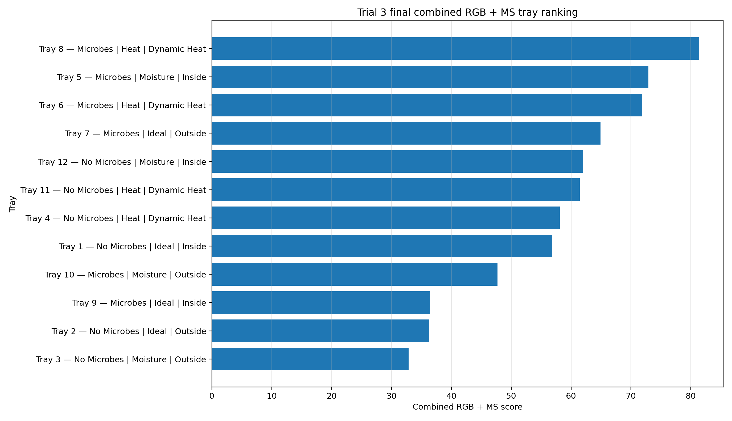

4. RGB and MS agreement
The RGB-versus-MS scatter chart checks whether visible growth evidence and multispectral vegetation-index evidence point in the same general direction. Trays close to the diagonal have broadly similar RGB and MS scores. Trays far from the diagonal may have strong visible emergence but weaker vegetation-index response, or the reverse.
Evidence agreement summary: RGB and MS broadly agree: 6; RGB stronger than MS: 3; MS stronger than RGB: 3.
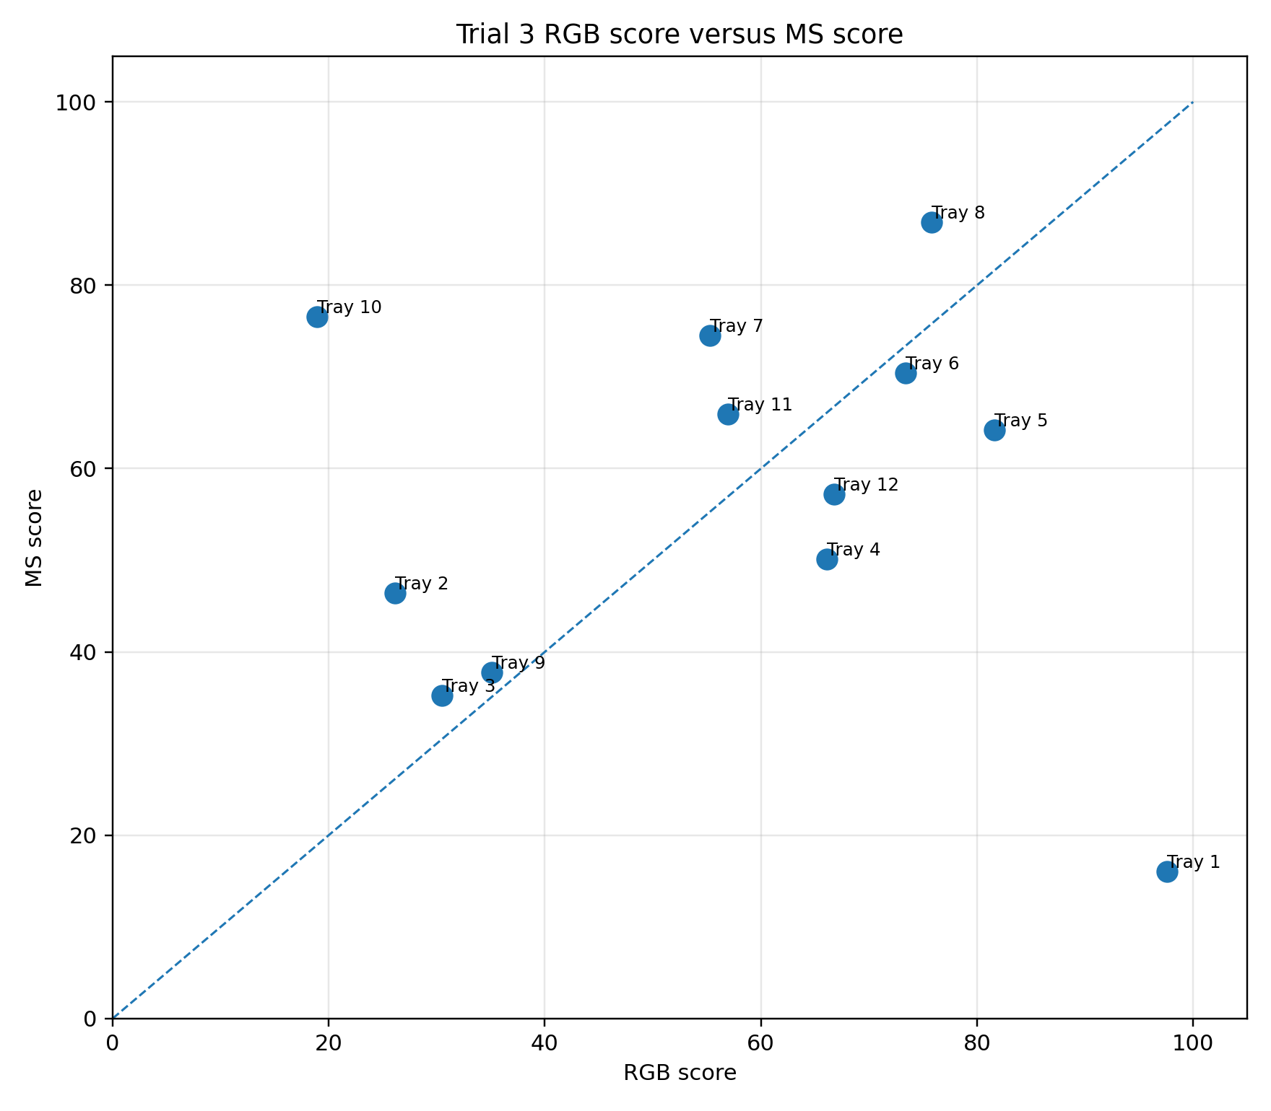

5. Microbes vs No Microbes
For microbe status, the highest mean combined RGB + MS score was recorded by Microbes (62.53).
Group | Tray Count | Trays | Mean Combined Rgb Ms Score | Mean Rgb Score | Mean Ms Score | Best Tray In Group
Microbes | 6 | Tray 5, Tray 6, Tray 7, Tray 8, Tray 9, Tray 10 | 62.53 | 56.686 | 68.375 | Tray 8
No Microbes | 6 | Tray 1, Tray 2, Tray 3, Tray 4, Tray 11, Tray 12 | 51.255 | 57.35 | 45.16 | Tray 12
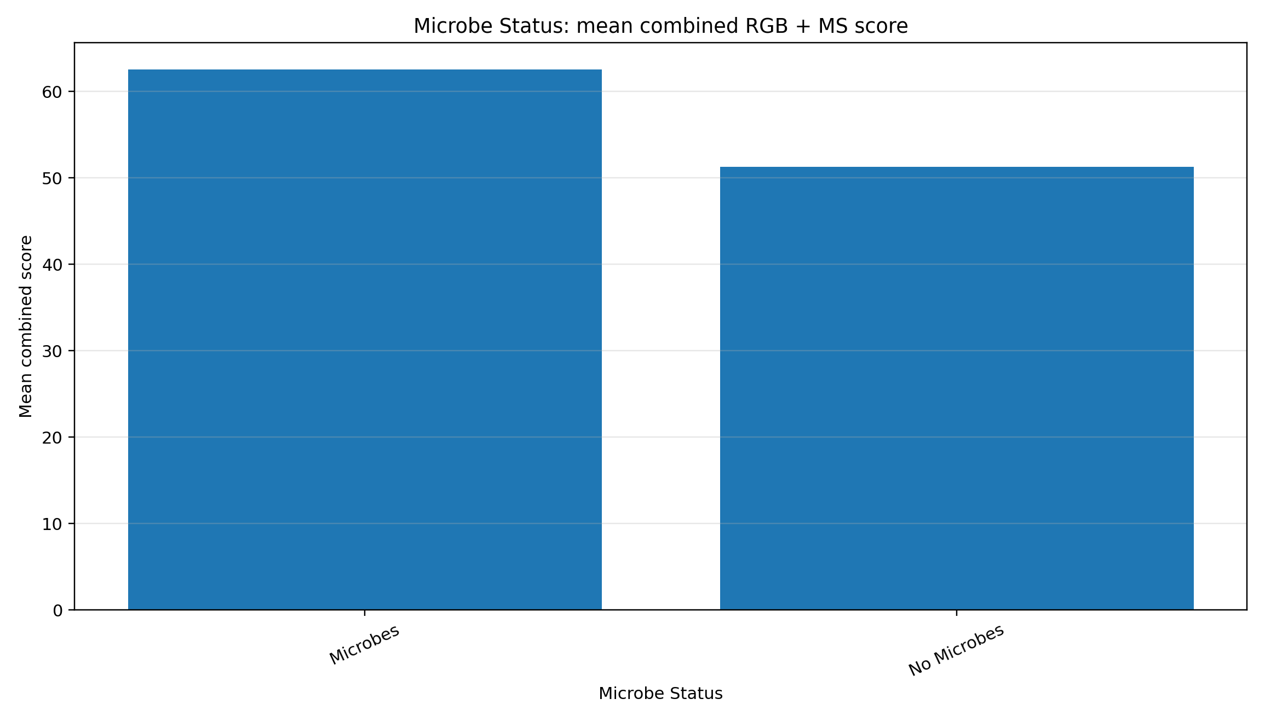

6. Ideal vs Heat vs Moisture
For treatment type, the highest mean combined RGB + MS score was recorded by Heat (68.20).
Group | Tray Count | Trays | Mean Combined Rgb Ms Score | Mean Rgb Score | Mean Ms Score | Best Tray In Group
Heat | 4 | Tray 4, Tray 6, Tray 8, Tray 11 | 68.201 | 68.067 | 68.335 | Tray 8
Moisture | 4 | Tray 3, Tray 5, Tray 10, Tray 12 | 53.871 | 49.452 | 58.29 | Tray 5
Ideal | 4 | Tray 1, Tray 2, Tray 7, Tray 9 | 48.606 | 53.534 | 43.678 | Tray 7
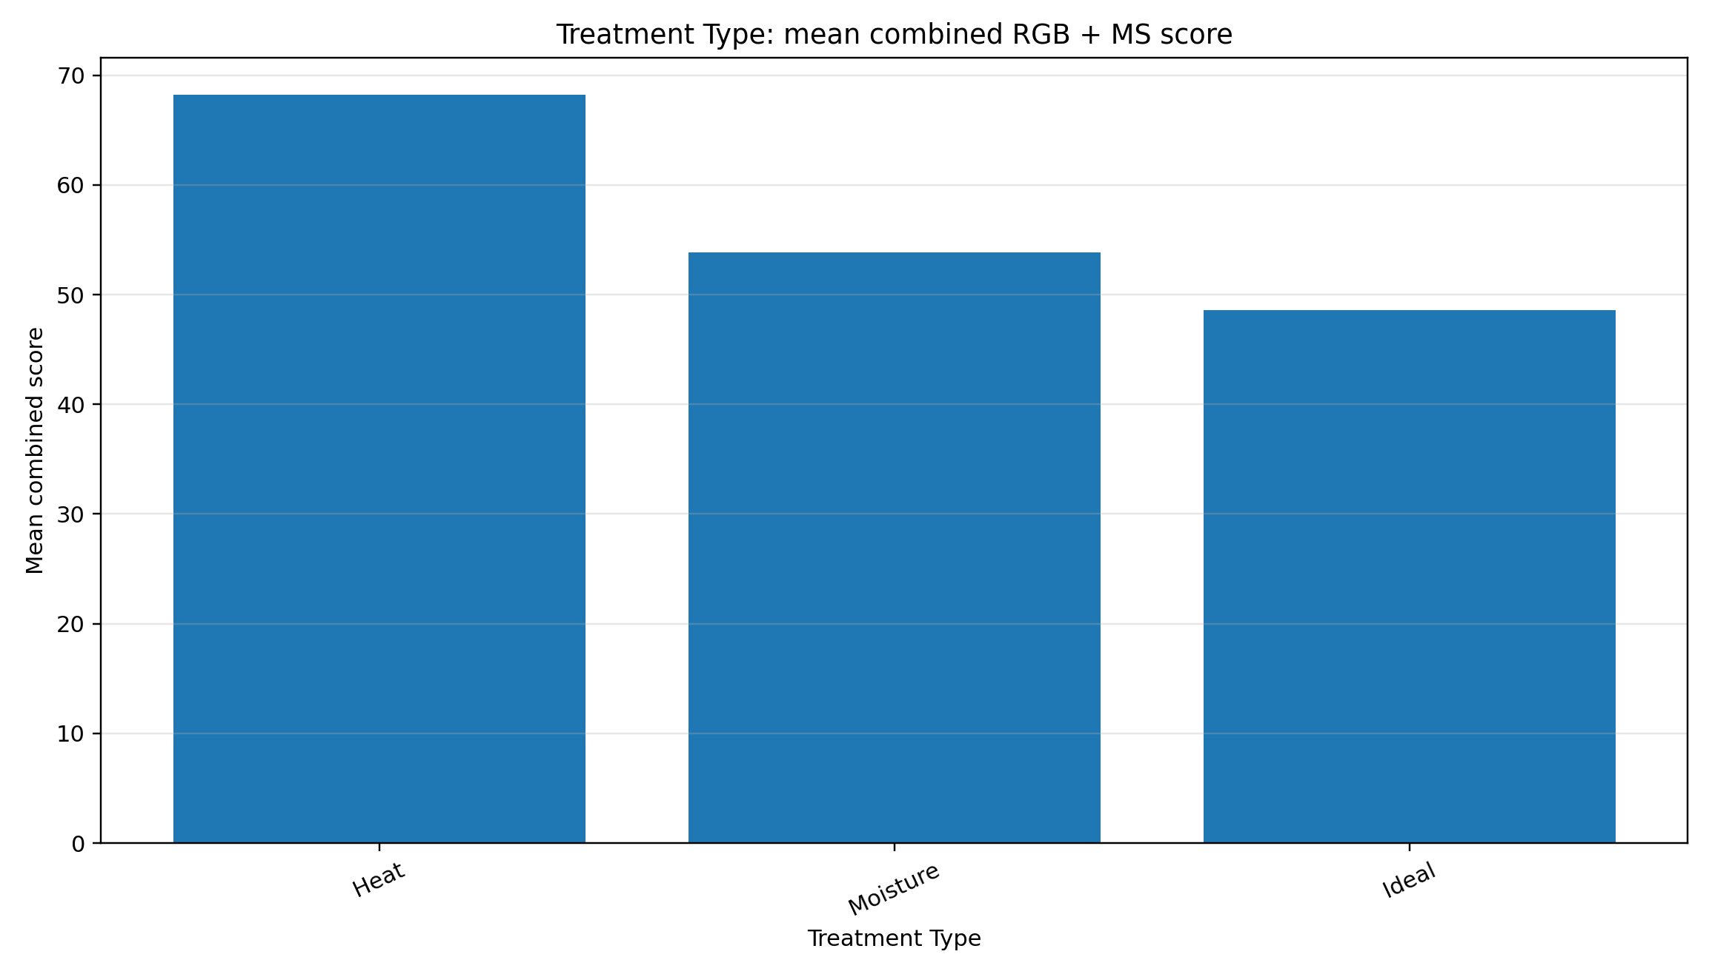

7. Ideal and Moisture: Inside vs Outside
Inside-versus-Outside synthesis was calculated only for Ideal and Moisture treatments because those trays had fixed environmental placement. Heat trays were excluded from this direct comparison because they were moved between inside and outside during the trial.
Treatment | Inside Trays | Outside Trays | Inside Mean Combined Score | Outside Mean Combined Score | Inside Minus Outside Combined Score | Inside Mean Rgb Score | Outside Mean Rgb Score | Inside Mean Ms Score | Outside Mean Ms Score | Interpretation
Ideal | Tray 1, Tray 9 | Tray 2, Tray 7 | 46.611 | 50.602 | -3.991 | 66.348 | 40.721 | 26.873 | 60.483 | Outside trays performed better on the combined RGB + MS score.
Moisture | Tray 5, Tray 12 | Tray 3, Tray 10 | 67.449 | 40.292 | 27.157 | 74.199 | 24.704 | 60.699 | 55.88 | Inside trays performed better on the combined RGB + MS score.
For Ideal, the Inside-minus-Outside combined score difference was -3.99. Outside trays performed better on the combined RGB + MS score.
For Moisture, the Inside-minus-Outside combined score difference was 27.16. Inside trays performed better on the combined RGB + MS score.
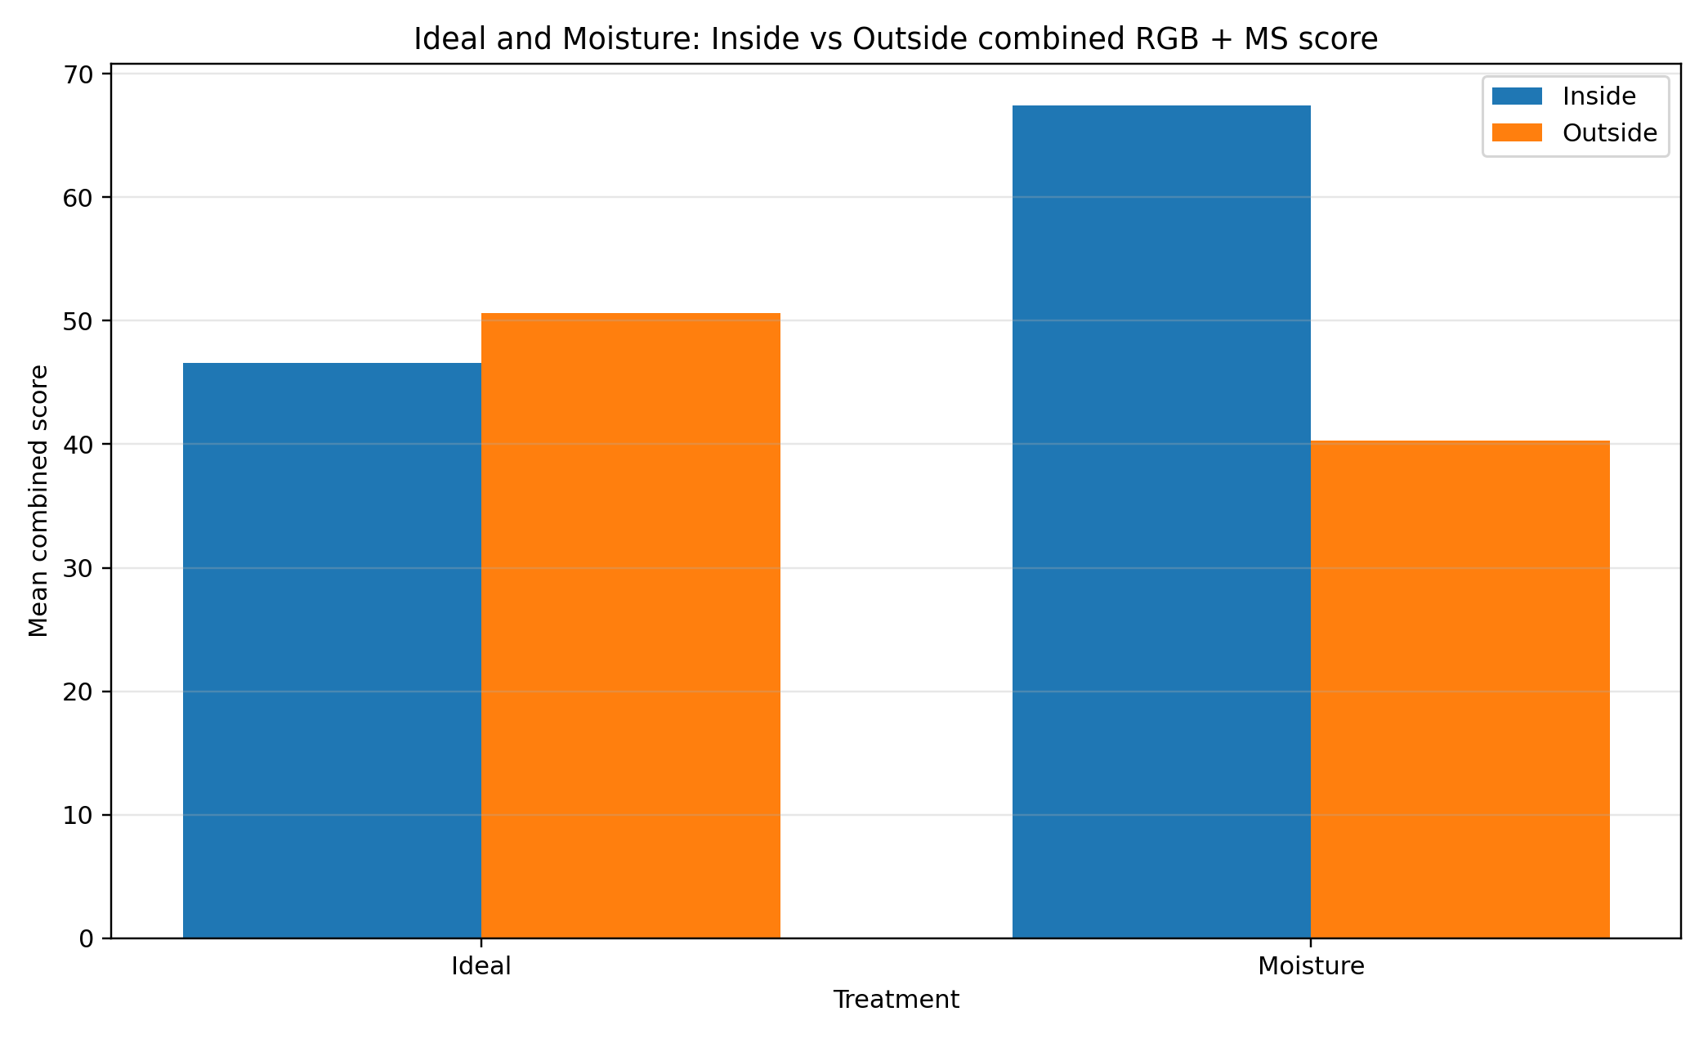

8. Day 7 observed and adjusted evidence
Across all trays, the combined RGB and MS workflow recorded 396 adjusted Day 7 cell records. These records are not direct observations. They are kept as a separate adjusted scenario to avoid mixing visible final-image evidence with estimated values.
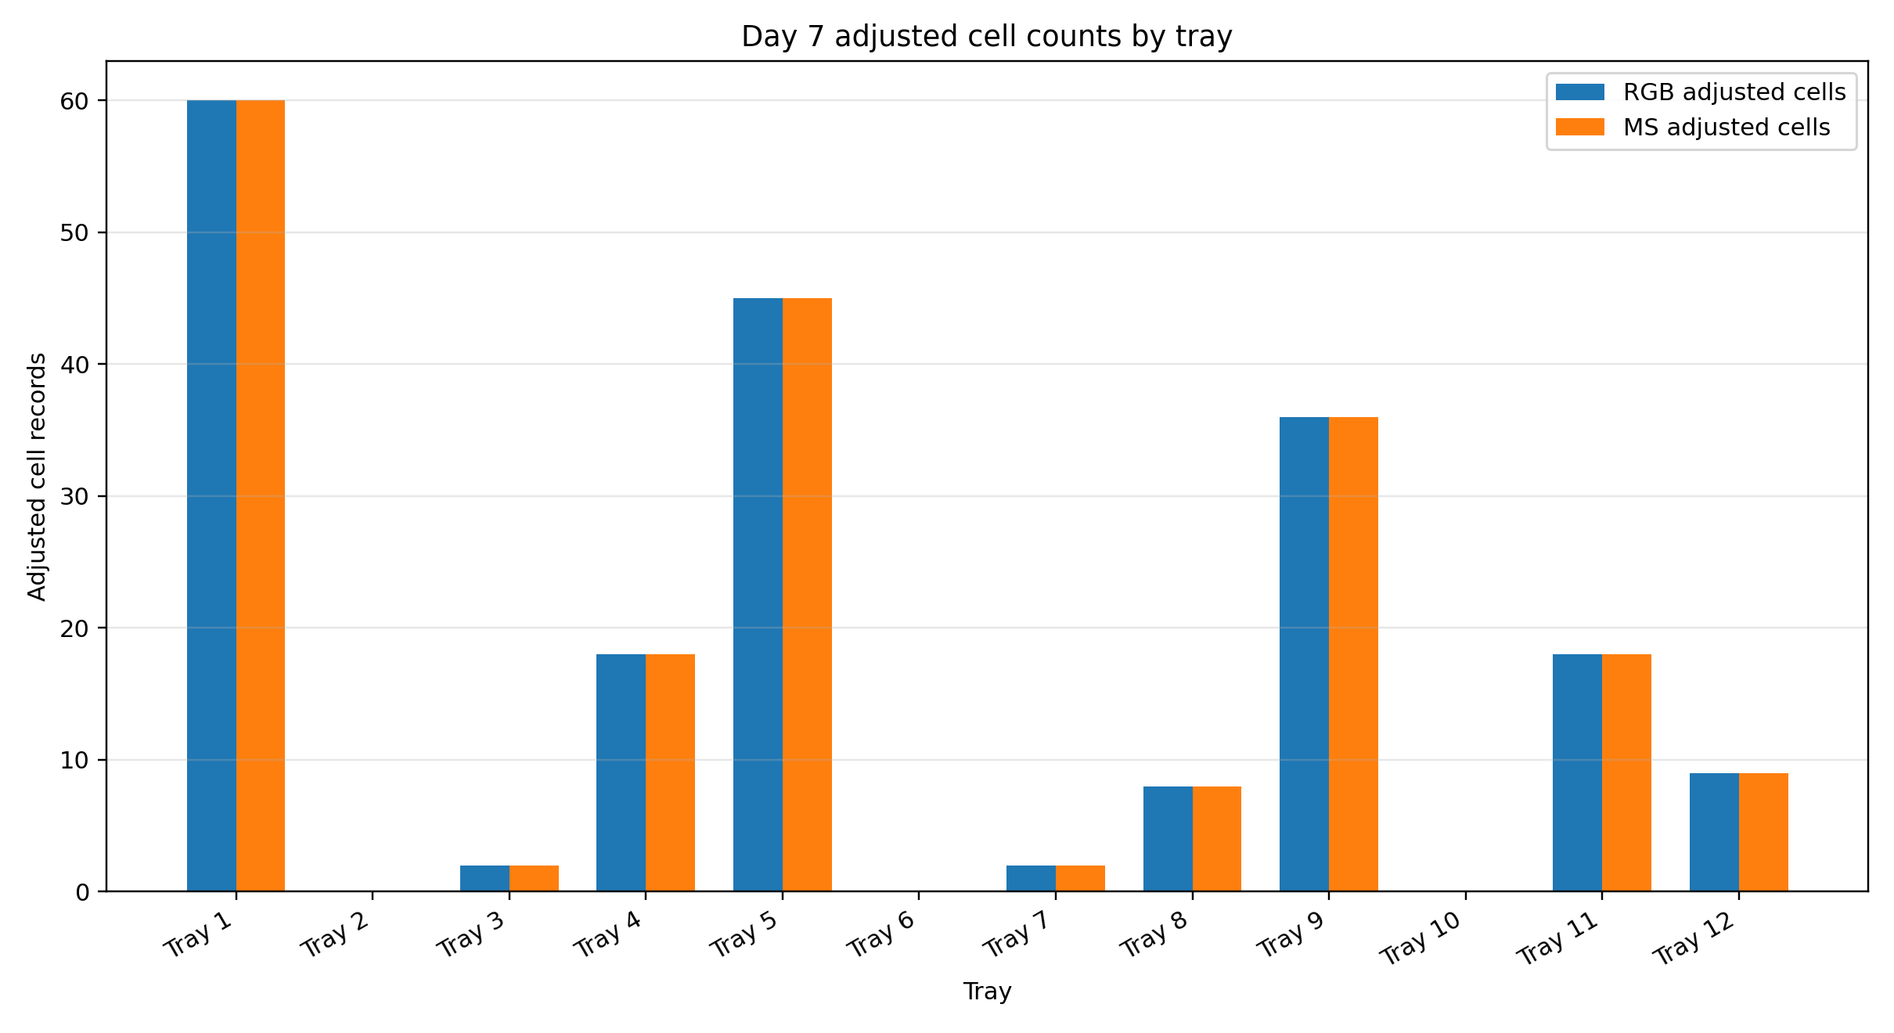

9. Description of generated CSV files
final_combined_tray_synthesis.csv: Main tray-level output. It combines RGB and MS evidence, includes final scores, ranks, observed/adjusted Day 7 indicators, and interpretation notes.
final_group_synthesis.csv: Group-level summary for Microbe Status, Treatment Type, Environment Group, Microbe × Treatment, Treatment × Environment, and Microbe × Environment.
final_inside_outside_synthesis.csv: Dedicated Inside-versus-Outside comparison for Ideal and Moisture treatments using combined RGB + MS scores.
input_file_inventory.csv: List of the input files checked by Script 09, including whether each file existed and how it was used.

10. Description of the Excel workbook
The workbook final_rgb_ms_synthesis_report.xlsx contains the Combined Tray Synthesis, Group Synthesis, Inside Outside Synthesis, Input File Inventory, and Read Me sheets. It is the easiest single file for checking final Trial 3 synthesis values.

11. Description of generated charts
01_final_combined_rgb_ms_tray_ranking.png: Final tray ranking using the combined RGB + MS score.
02_rgb_vs_ms_score_scatter.png: Agreement check between RGB and MS evidence streams.
03_combined_score_by_microbe_status.png: Mean combined score for Microbes and No Microbes.
04_combined_score_by_treatment.png: Mean combined score for Ideal, Heat and Moisture treatments.
05_inside_outside_combined_score_ideal_moisture.png: Inside vs Outside combined score for Ideal and Moisture treatments.
06_day7_adjusted_cells_rgb_ms.png: Adjusted Day 7 cell counts from RGB and MS workflows by tray.

12. Interpretation limitations
The synthesis combines different kinds of evidence. RGB metrics are based on visible emergence and green cover, whereas MS metrics are based on relative NDVI and NDRE. These do not measure the exact same biological property, so perfect agreement is not expected.
The multispectral indices should be described as relative image-derived indices unless reflectance calibration is confirmed. Results can be affected by shadows, soil moisture, exposure, band alignment, cell-zone placement and the amount of soil visible within each cell.
The final combined score is a descriptive integration score. It is appropriate for ranking, reporting and visual comparison, but it should not be used as a formal statistical significance test.

